Plugin Usage Instructions:

1. How to create a course
Frontend url for all courses

Go To Admin Panel
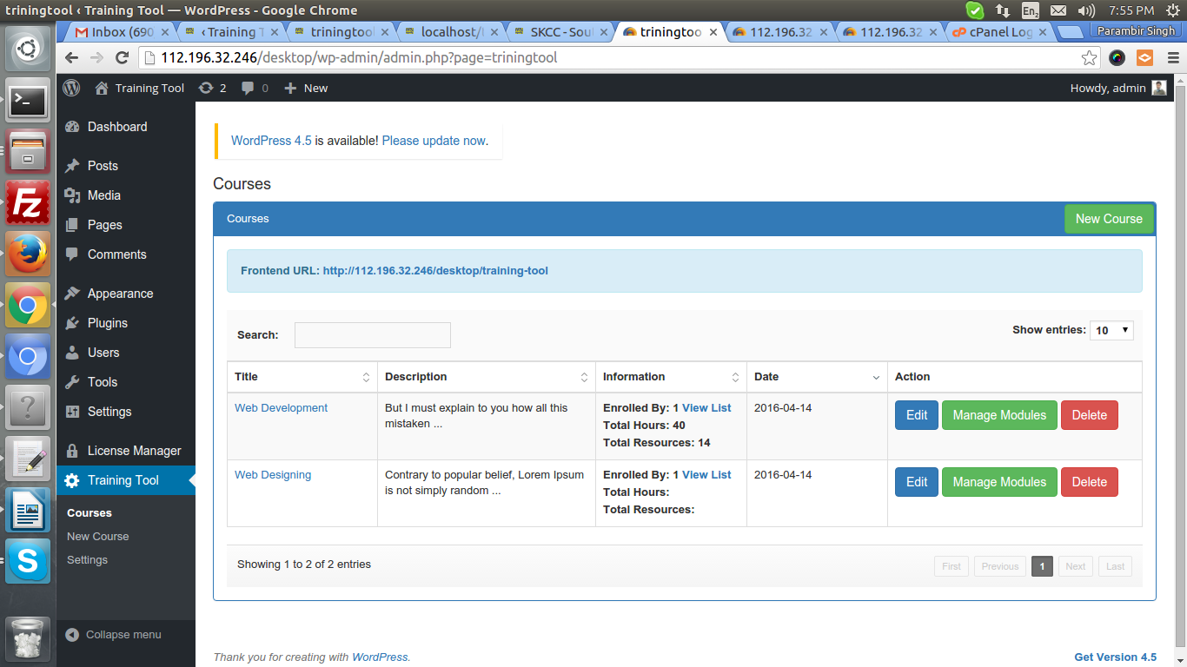
Click on this
button
List of courses
Add New Course
Manage Modules of a course

You can Edit and Delete a course. On Deletetion of a course, all modules, lessons, resources, project exercises inside course will also delete.
Add new Course Page
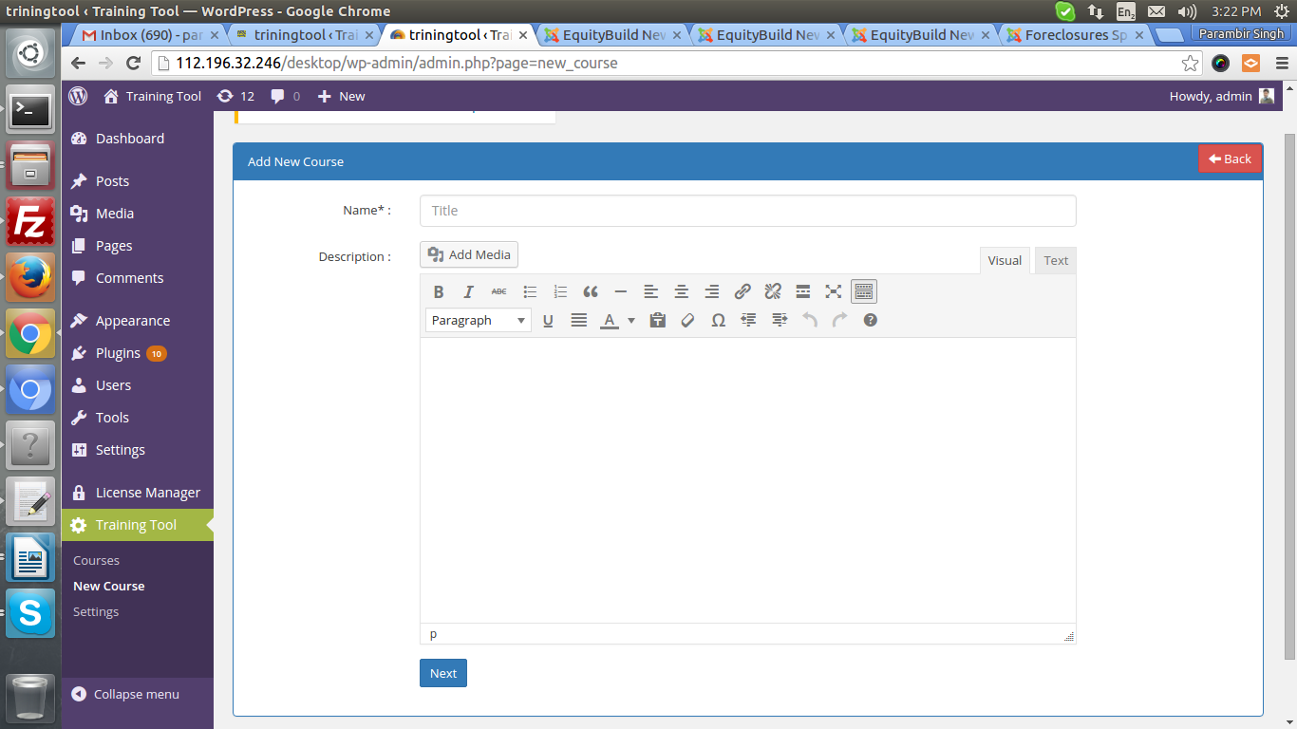
On click Next button, data saved in DB and redirect to manage
modules page of course. Where you can add modules.

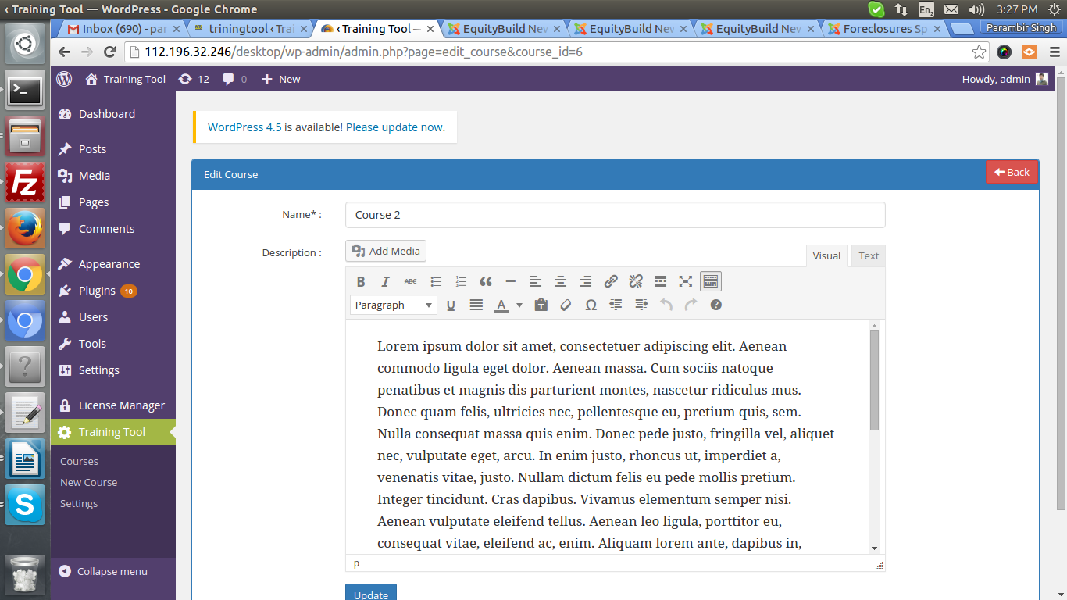
Edit Course title And Description
Add Course Exercise,
That will append as a
Last step of course
Page To manage Modules, Course Exercise
And mentor call. You can see list of modules
Manage Lessons
Inside a Module
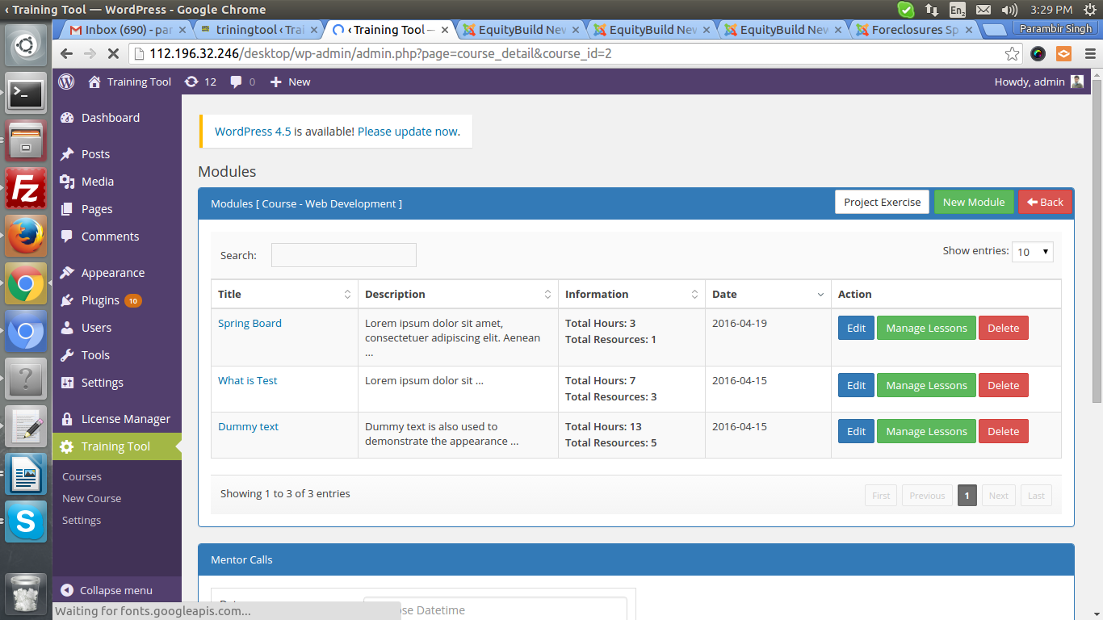

Simlilarly as you can add, edit, delete module by clicking on button accordingly.

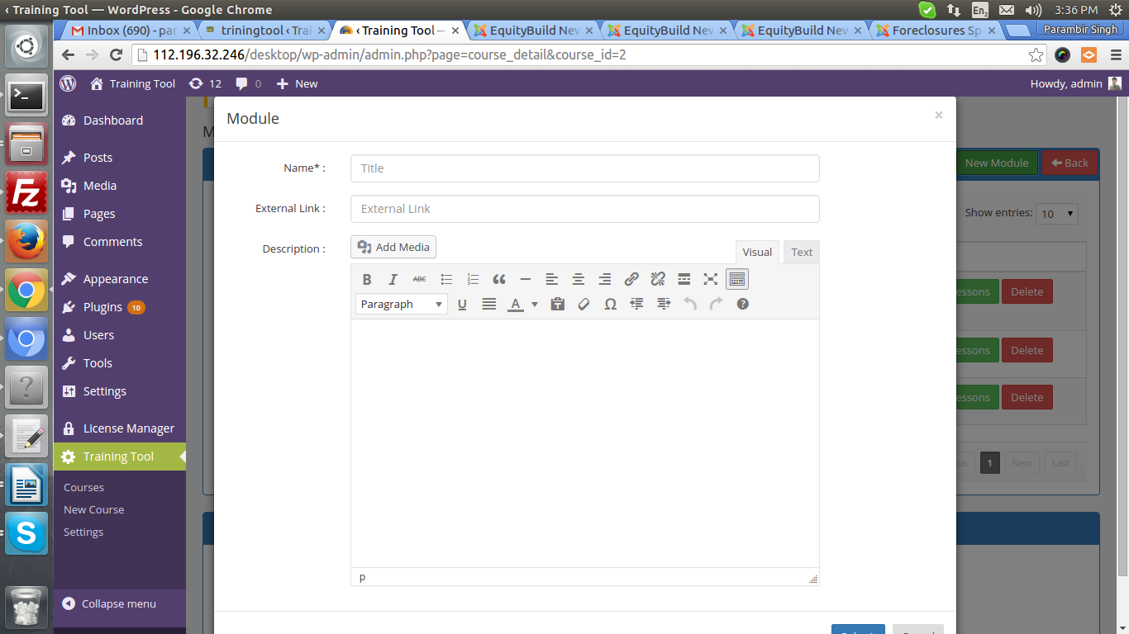
Add Module popup, You can add module Title, description and external / internal
link . Whenever it appears on frontend, Title of module
linked with link entered at backend.
Here you find mentor calls for a course. Admin can create new call
For a course, once click on submit, email goes to all enrolled users (
If “Notify Enrolled Users” is checked.
All other older call status changed to cancelled and current call is active.
You can also cancel call or delete call.

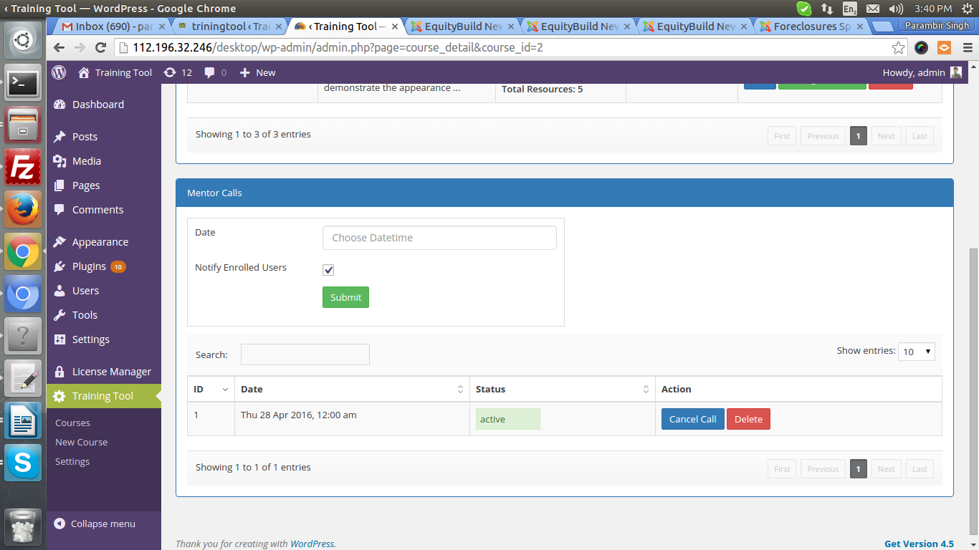

Add Exercise for a course – This project exercise append at the end
of course (if Enable checkbox is checked).

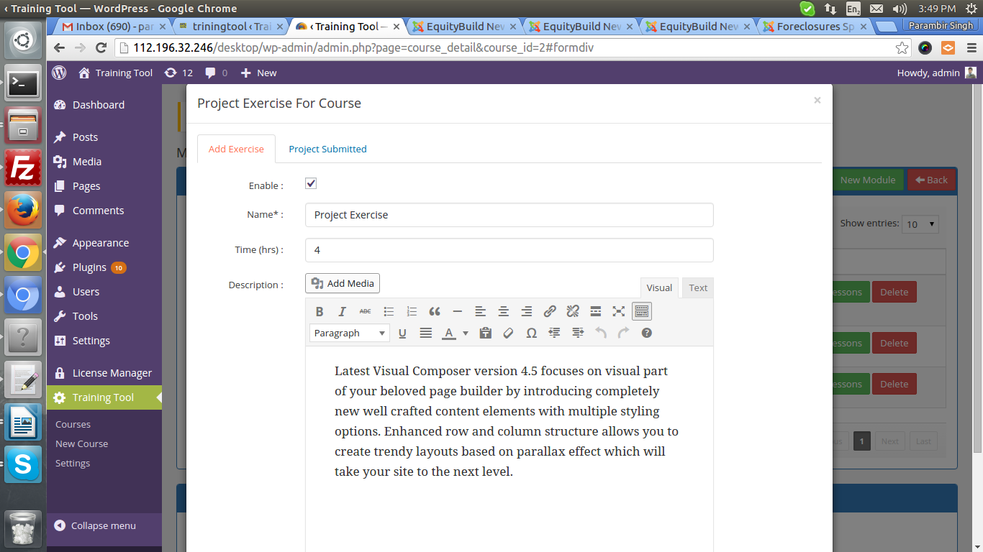

All project links submitted
by users for project exercise apperaed in this section

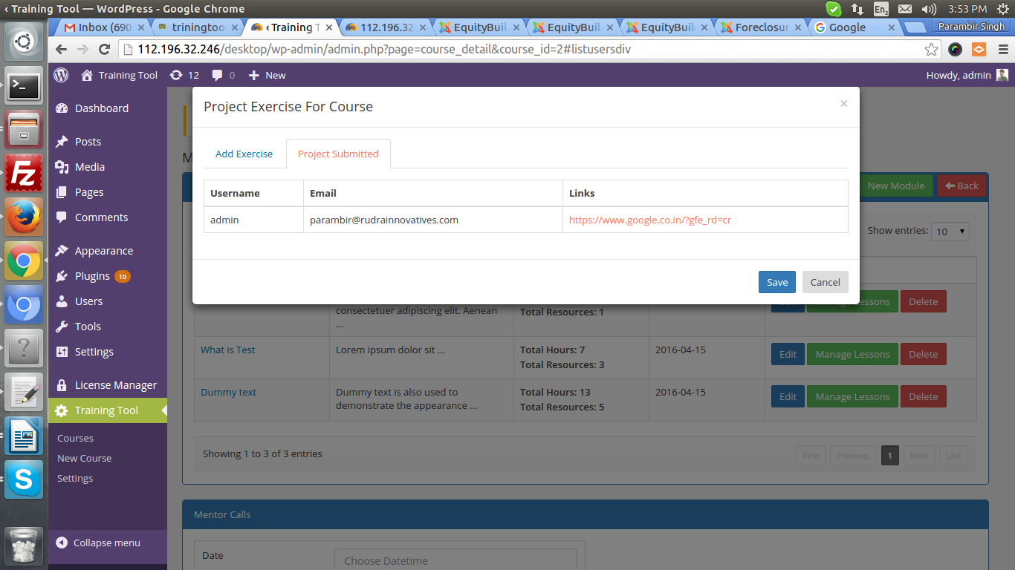

This page comes under Module to manage Lessons. Like other pages, you
Can add, edit, delete a lesson. Here you can also find Project exercise button.
Same as previous step, you can add project exercise for a module also
This project exercise will append at the end of module.

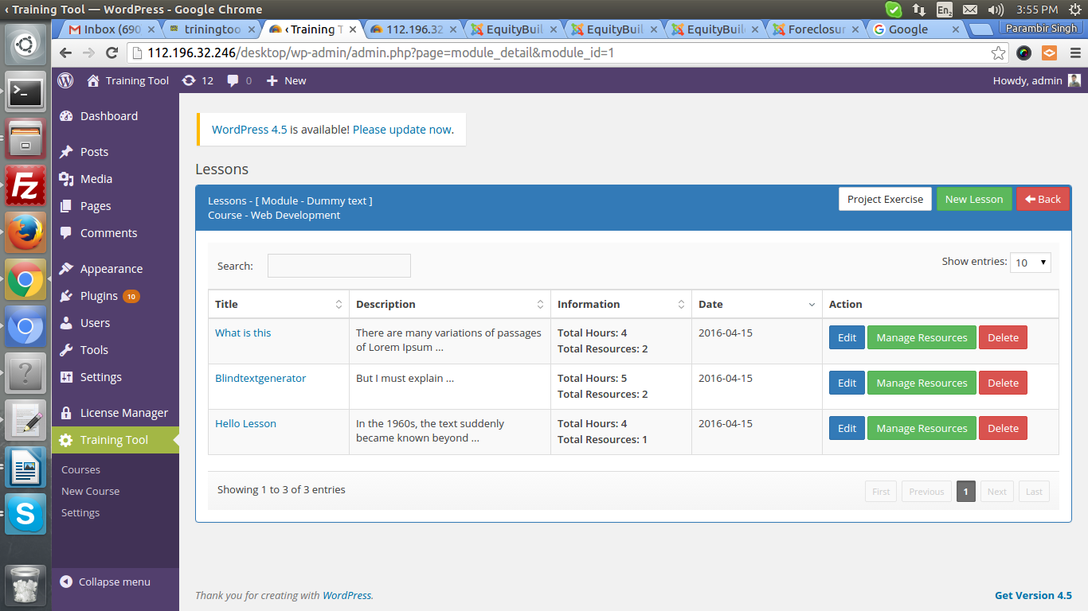
Manage Resources
(Like a task, that used to mark
as complete or not complete)
This pages shows list of resources for a lesson. You can add, edit,
Delete resource. Here you need to enter also hours to complete task.
Full time to complete a course basis on Resources Time and
project exercise.

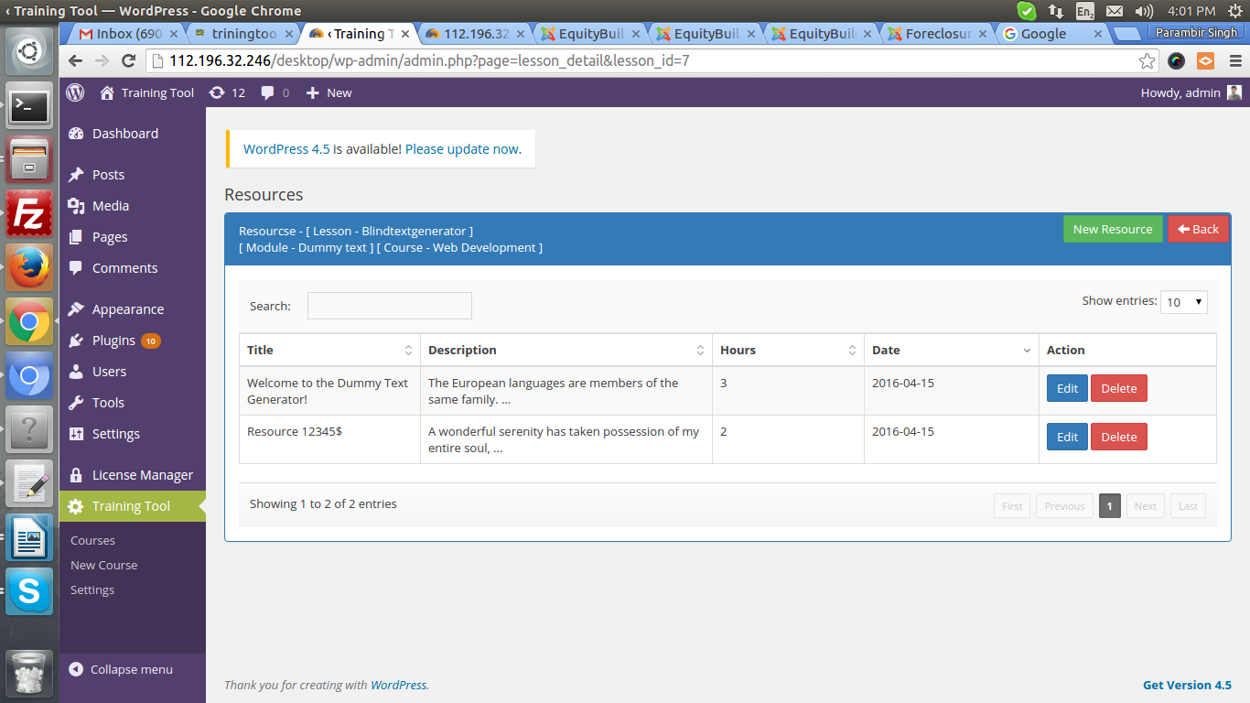

You can add resouce and
provide time to complete (in hrs)

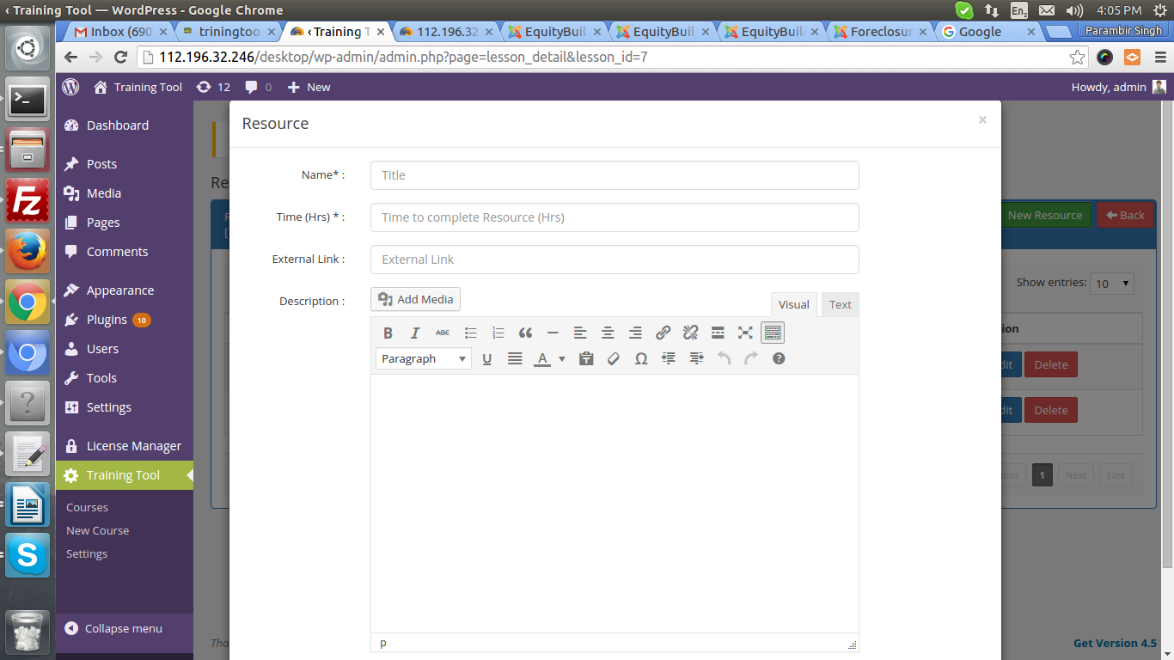

FRONTEND – Screenshots
Above 3 courses are not enrolled by current user. 4Th
one is enrolled. When you click on title of Course
It gives you title and description of course only
(not full course). But when click on Enroll button, user will
be enrolled for course and see full course.

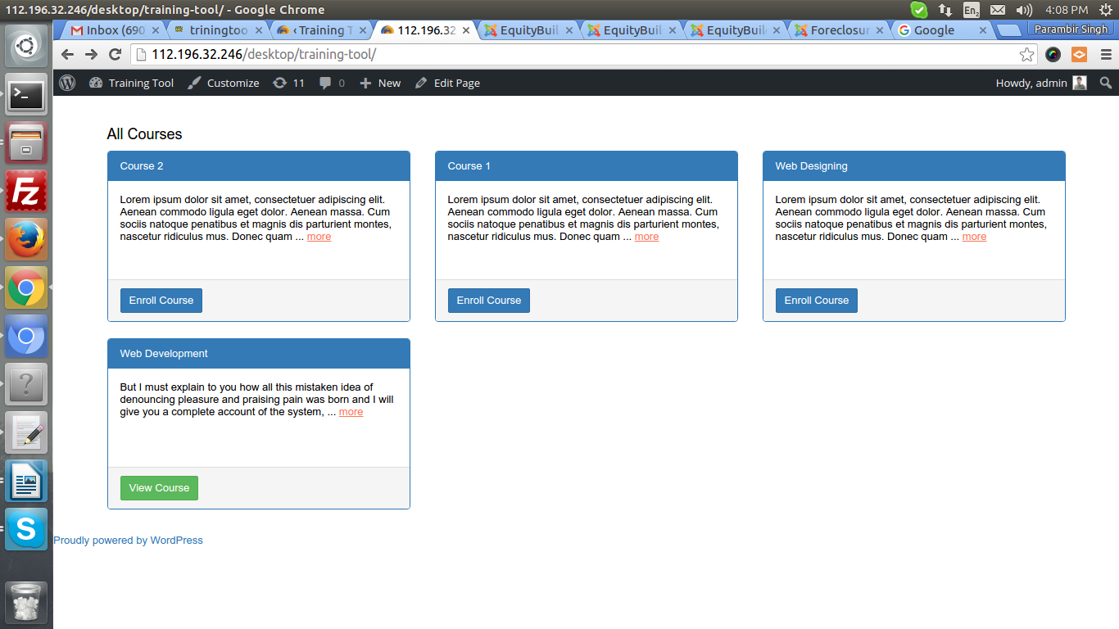

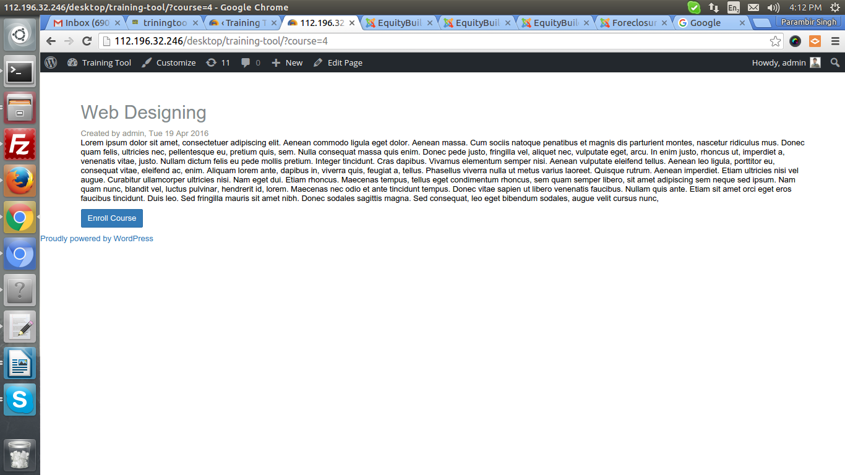
Page appear, when click on title of course. You can also enroll
For course from here.

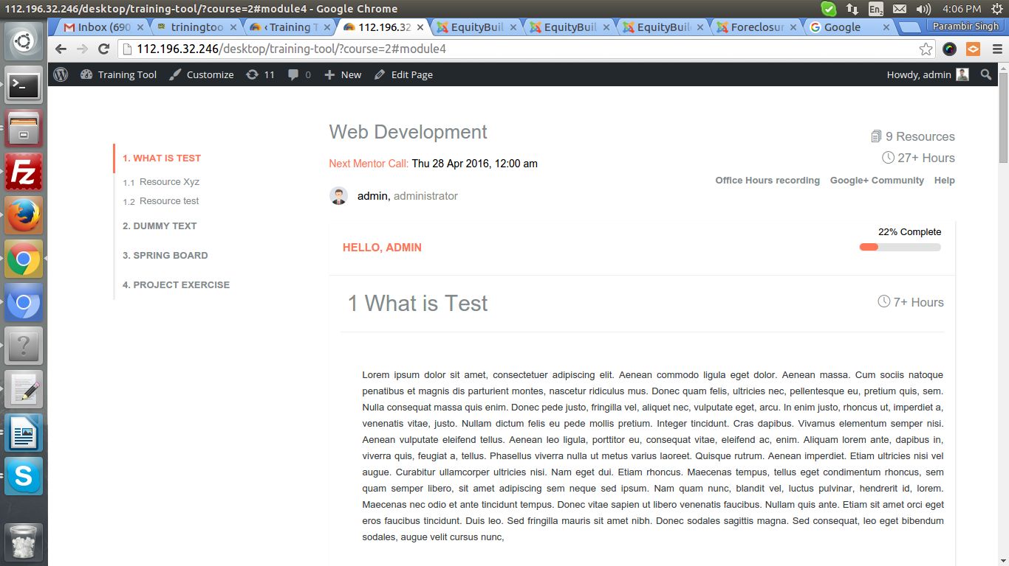
This page visible to only Enrolled users

Floating header

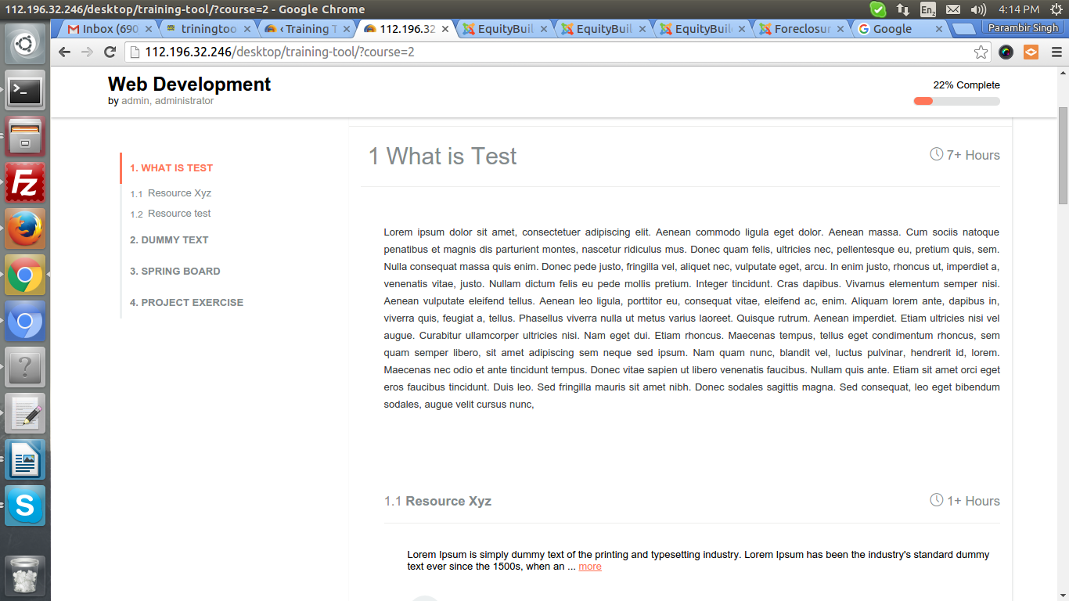

Mark complete / Unmark
Resource
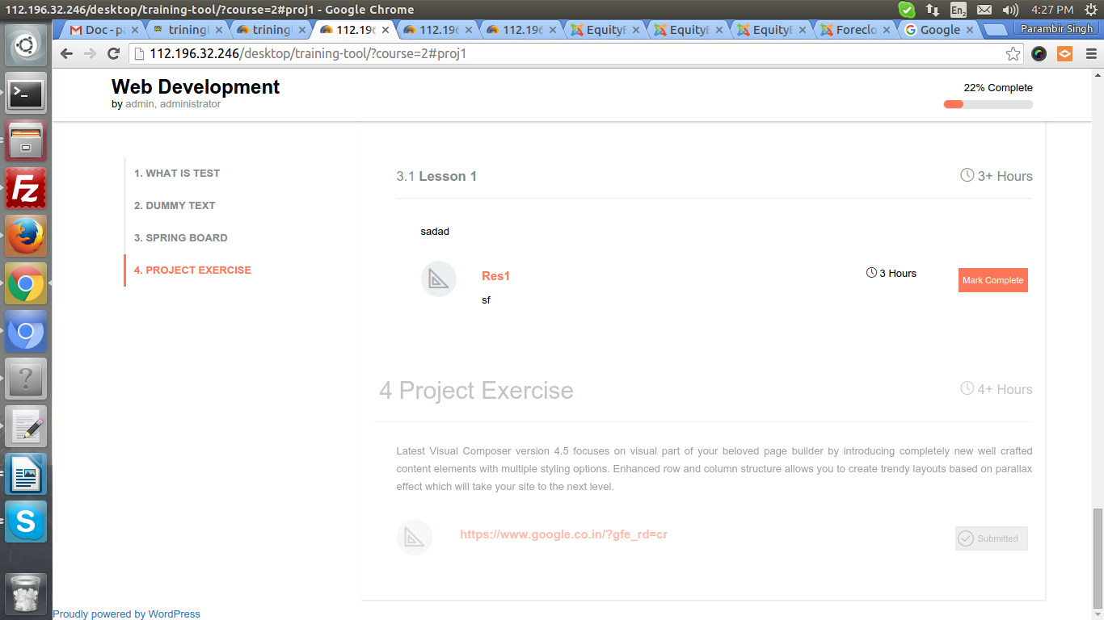
Submit Project Exercise for
a course. Already submitted,
That's why it is disabled

Plugin Key functionality:
Licence Key manger. You need to install this plugin on site, from where
you want to manage licences for Training Tool Plugin. You can add, Edit,
Delete Licence Key here. Once you created a Licence key, you can give to
Client, where the plugin Training Tool should be installed.

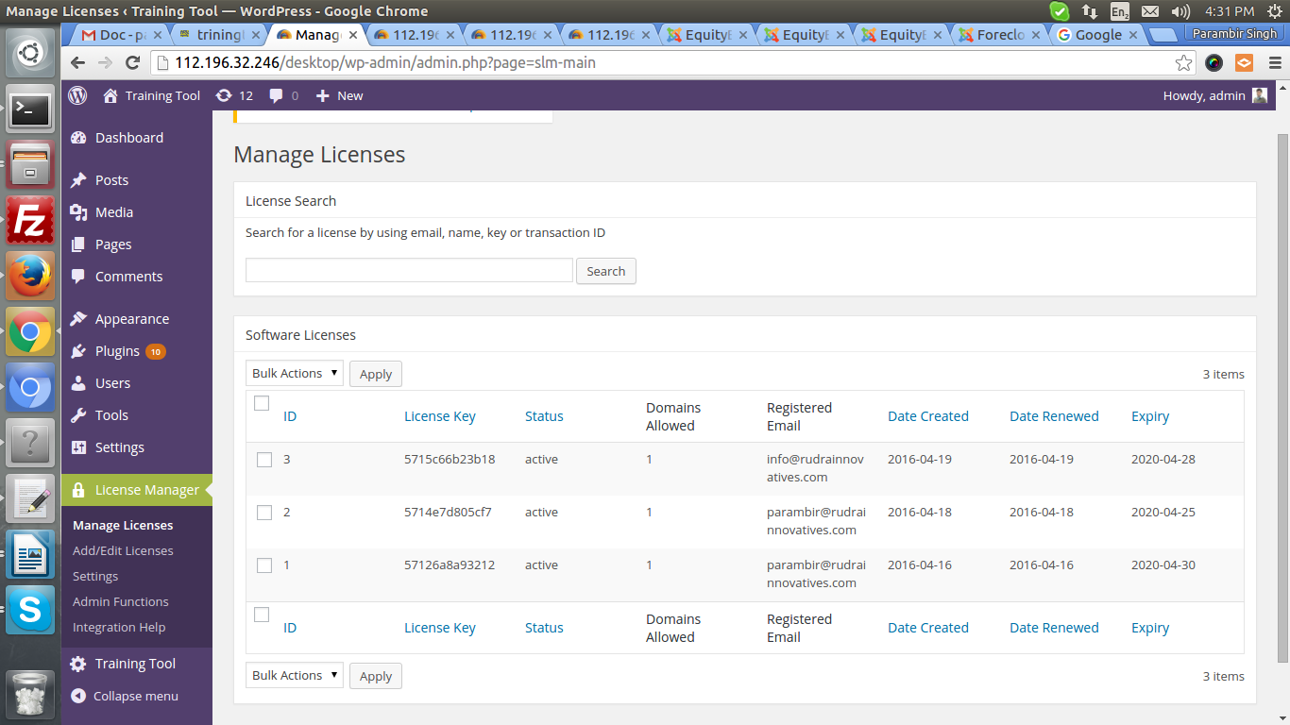
We have set these fileds in
Plugin code for licencing.
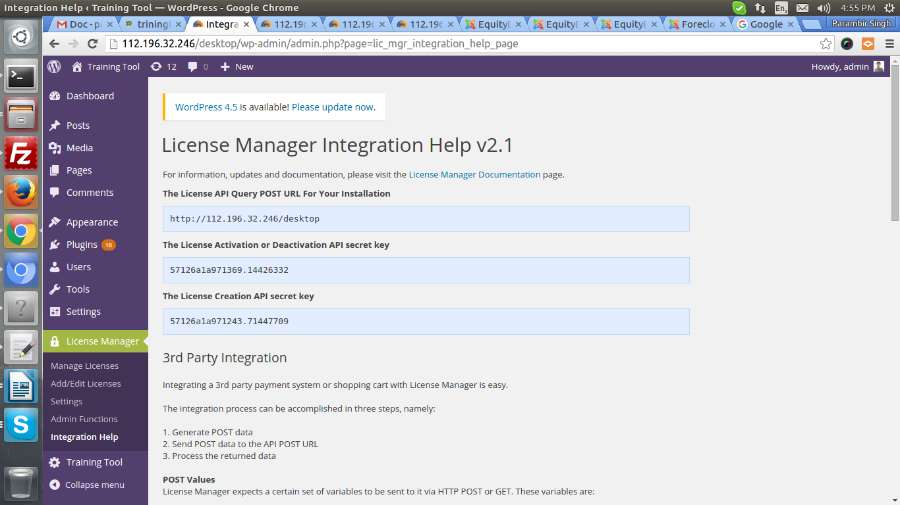

When any user install this plugin, after installtion below screen appears

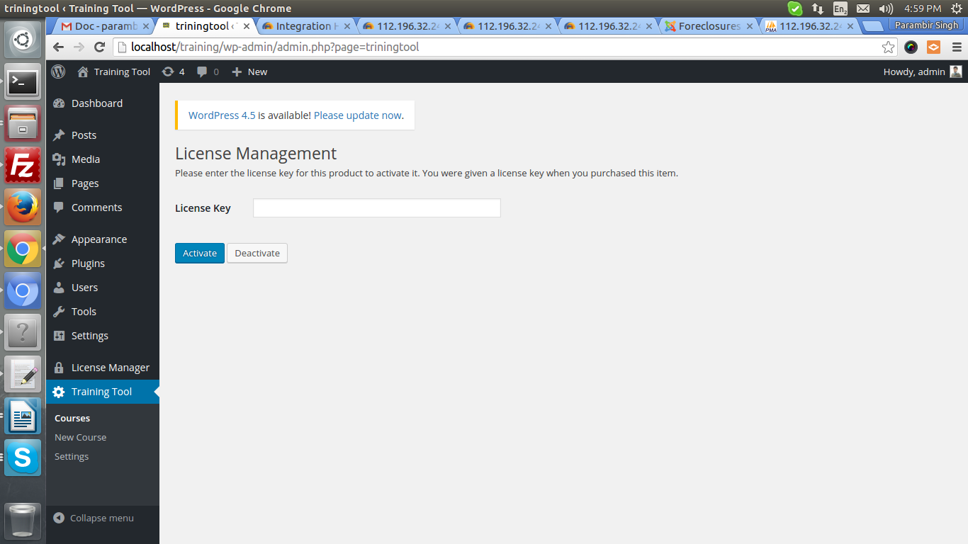
Here user need to enter licence key
In order to use this plugin

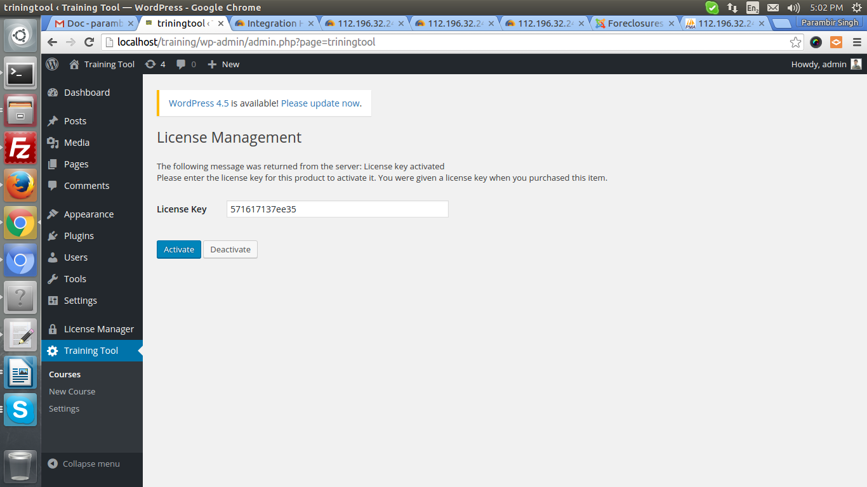
I entered licence key and it accept.
After refreshing page. You can see plugin content

Page coming after refresh.

